**Task - 1**

**Name :** Haritha N

Email ID : [Harithanatarajan321@gmail.com](mailto:Harithanatarajan321@gmail.com)

**Task Title**: Responsive Company Member Team Page

**Task Description**: The first task involves developing a responsive Company Member Team Page. The web page includes Company details and the list of team members working in the company. The primary goal is to utilize HTML and CSS to create the website and make the website responsive across various devices. This project aims to showcase coding skills, creativity, and attention to detail in implementing the design reference effectively. The layout and styling inspiration of the web page is done with the reference design provided in the file.

**Steps Taken:**

1. **HTML Structure:** Created the HTML structure based on the design reference, ensuring semantic markup and accessibility standards. Used Various HTML tags to develop the layout of each element on a web page.

2. **CSS Styling:** Utilized CSS to style the HTML elements according to the design specifications including fonts, colors , backgrounds , spacing, pointer, border alignment.

3. **Responsive Design:** Implemented media queries and flexible layout techniques to ensure responsiveness across various devices and screen sizes.

**Challenges Faced:**

**Responsive Layout:** Adapting the design to ensure responsiveness across different devices posed a challenge, especially in handling complex layouts and interactions.

**Solutions Implemented:**

Media Queries and Flexbox Layout Module played a major role to make the web page responsive.

**1.Media Queries:** Implemented media queries to adjust layout and styling based on screen size, ensuring optimal display across devices.

**2.Flexbox Layout Module**: Implemented Flexbox Layout Module for arranging items in rows or columns. Flexbox offers space distribution between items and powerful alignment capabilities.

**Learnings:**

1. **HTML Structure:** Learned various HTML tag and its properties.
2. **CSS Techniques:** Learned advanced CSS techniques such as

* **Flexbox Layout Module**: Used Flexbox to streamline page structure and enhance responsiveness.
* **Media Queries:** Gained a deeper understanding of responsive design principles and techniques for creating adaptable layouts using Media Queries.

**Project Update:**

The responsive Company Member Team page has been successfully developed, adhering to the design reference provided. The web page is developed with Markup language called Hyper Test Markup Language(HTML) and Style sheet language called Cascading Style Sheets(CSS). The page is fully functional and responsive, showcasing the Company Member Team information effectively across various devices and screen sizes.

**Responsive to various devices:**

1)IPad Air:

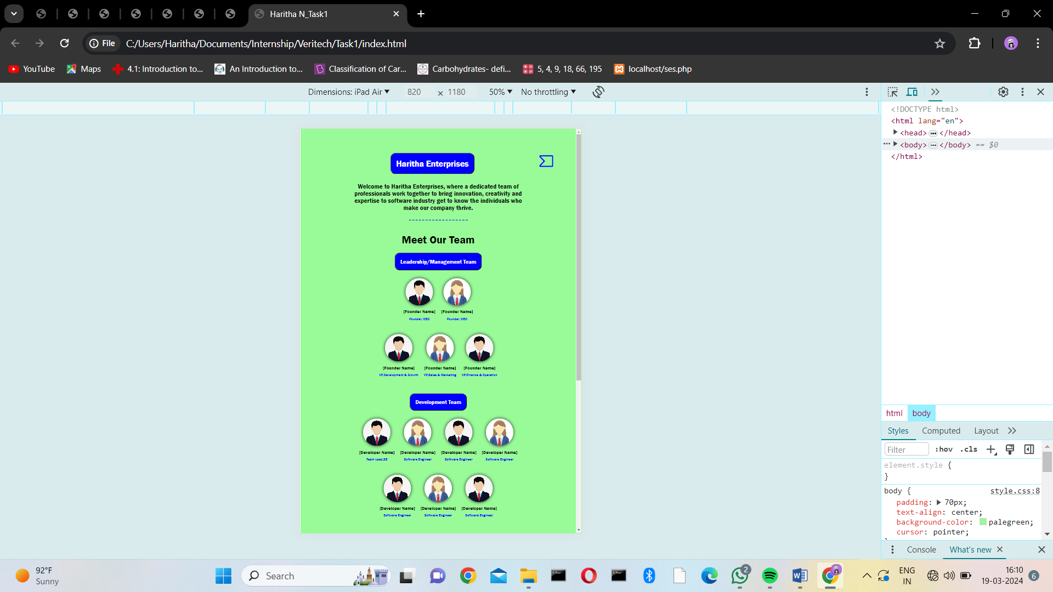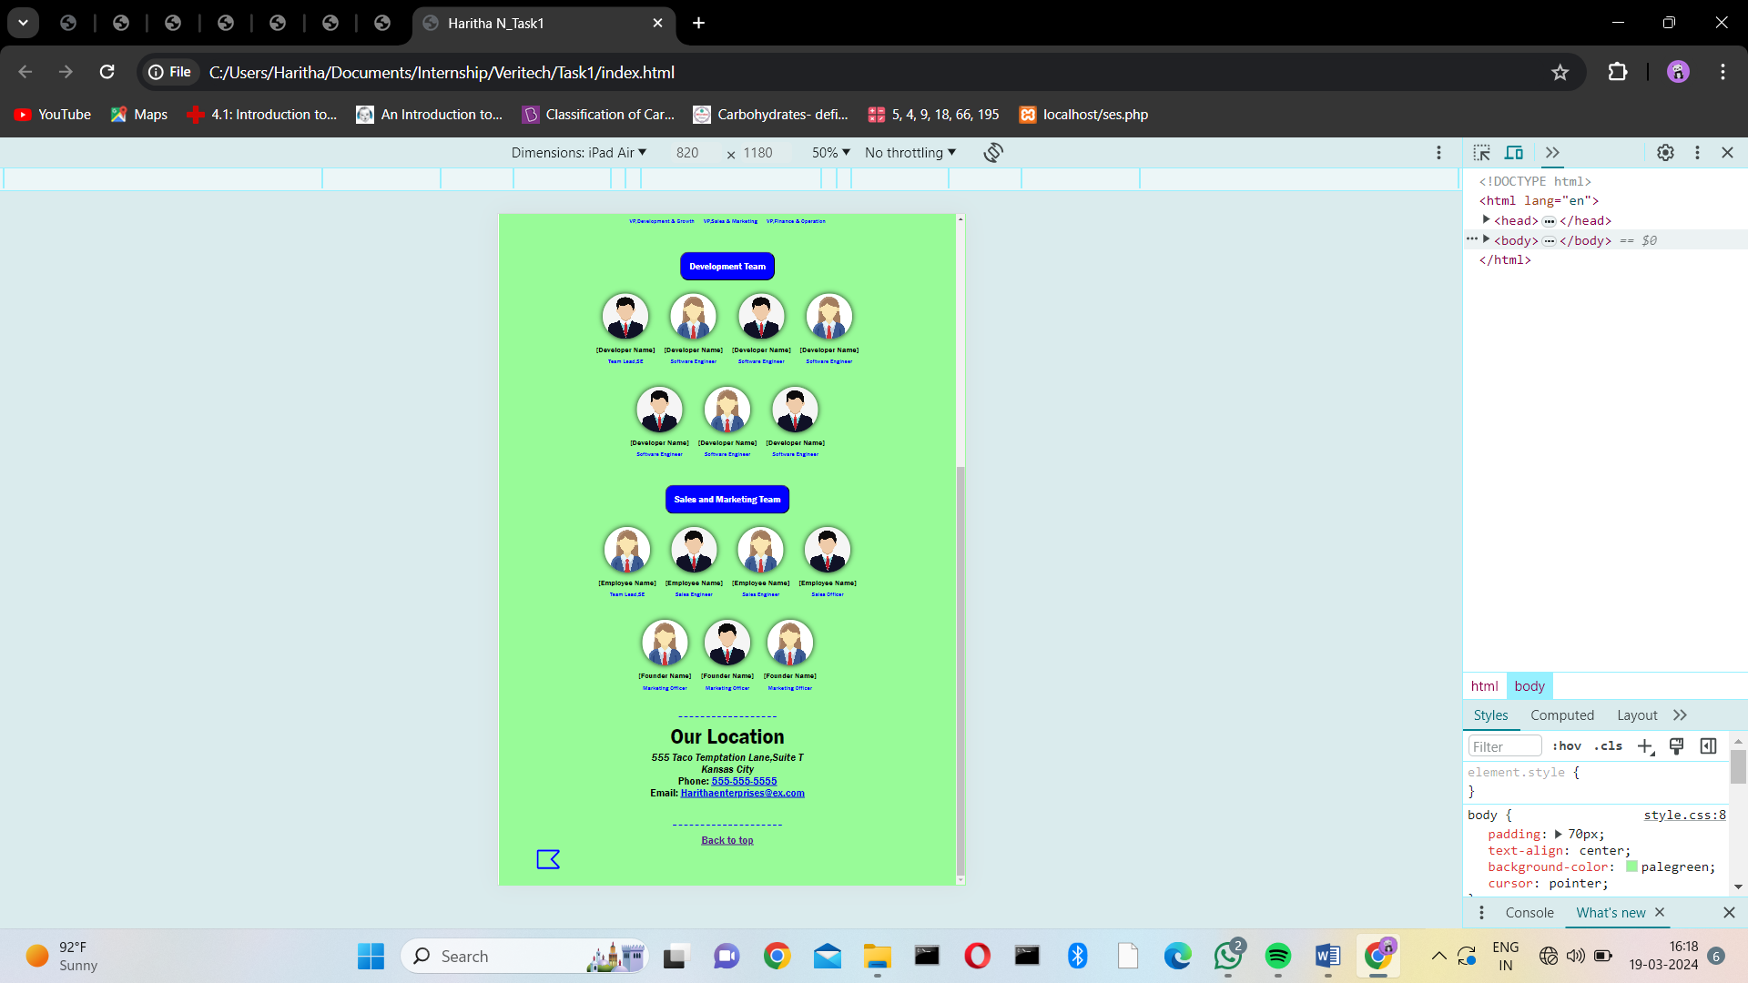

2)Mobile devices:

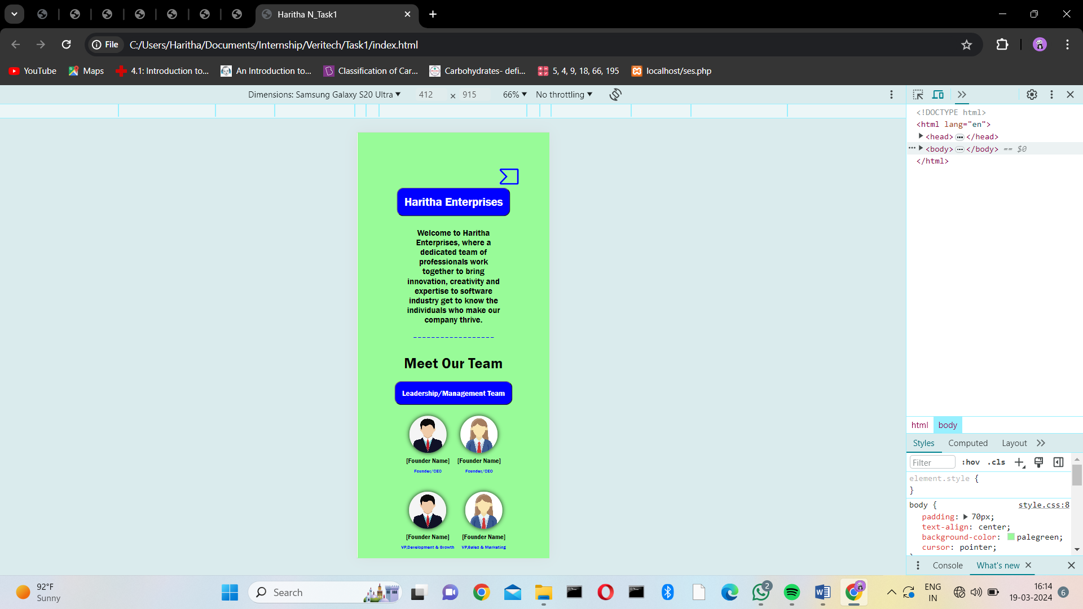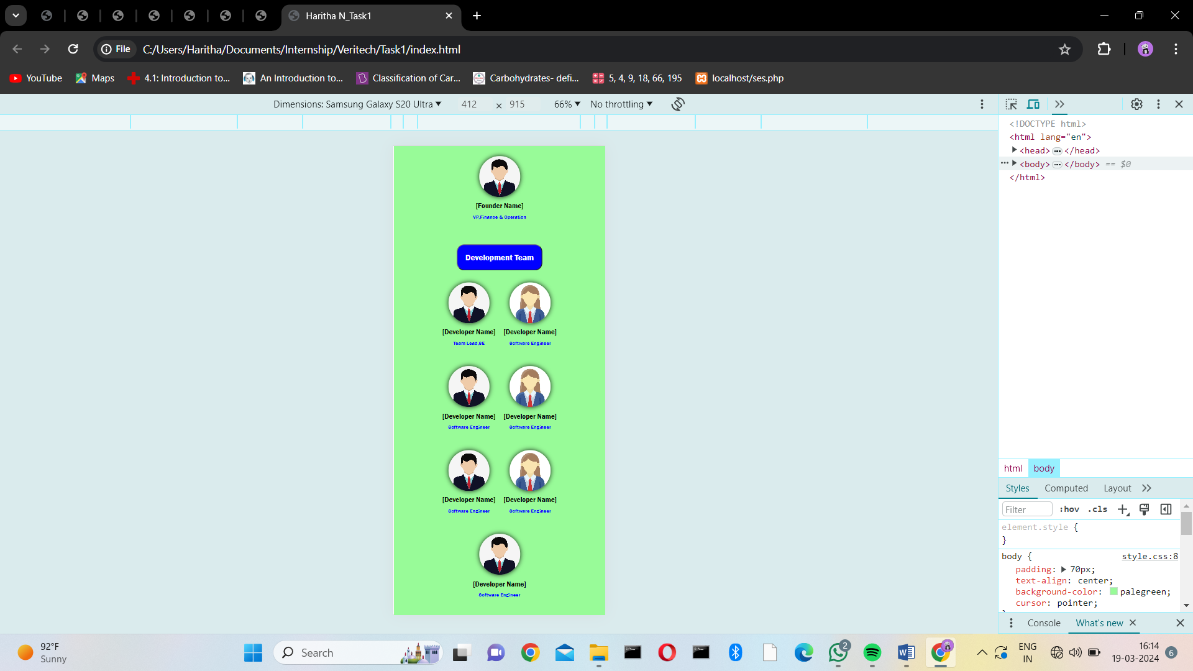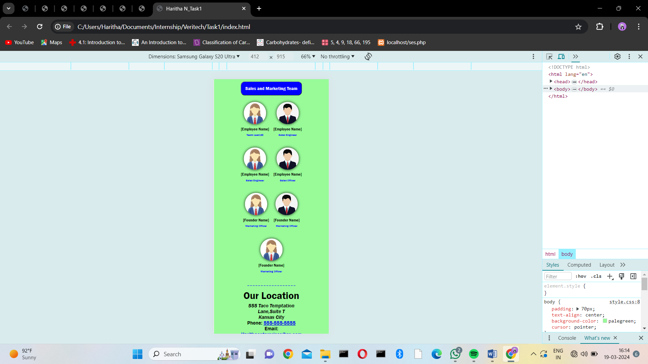

3)Laptop:

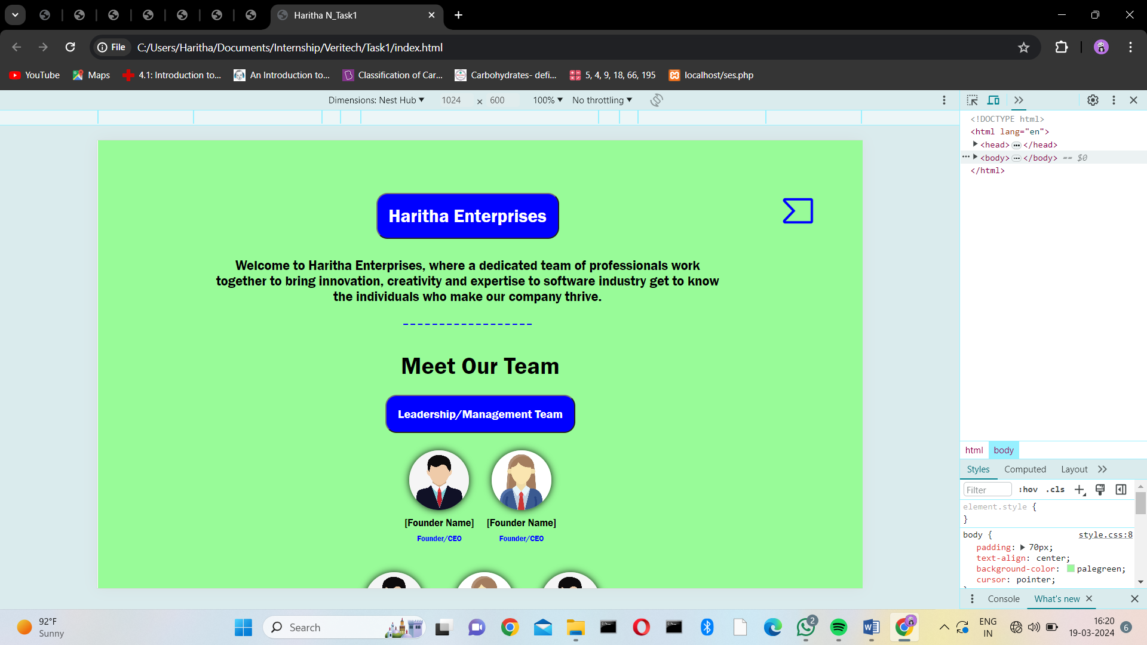

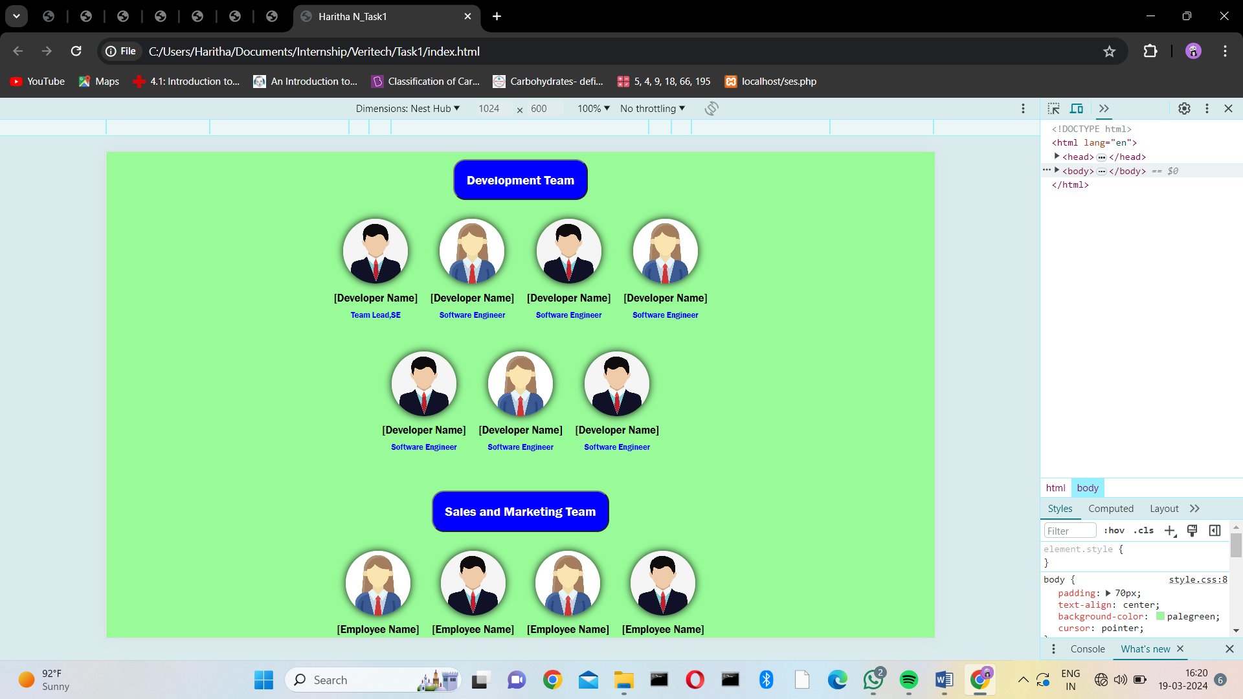

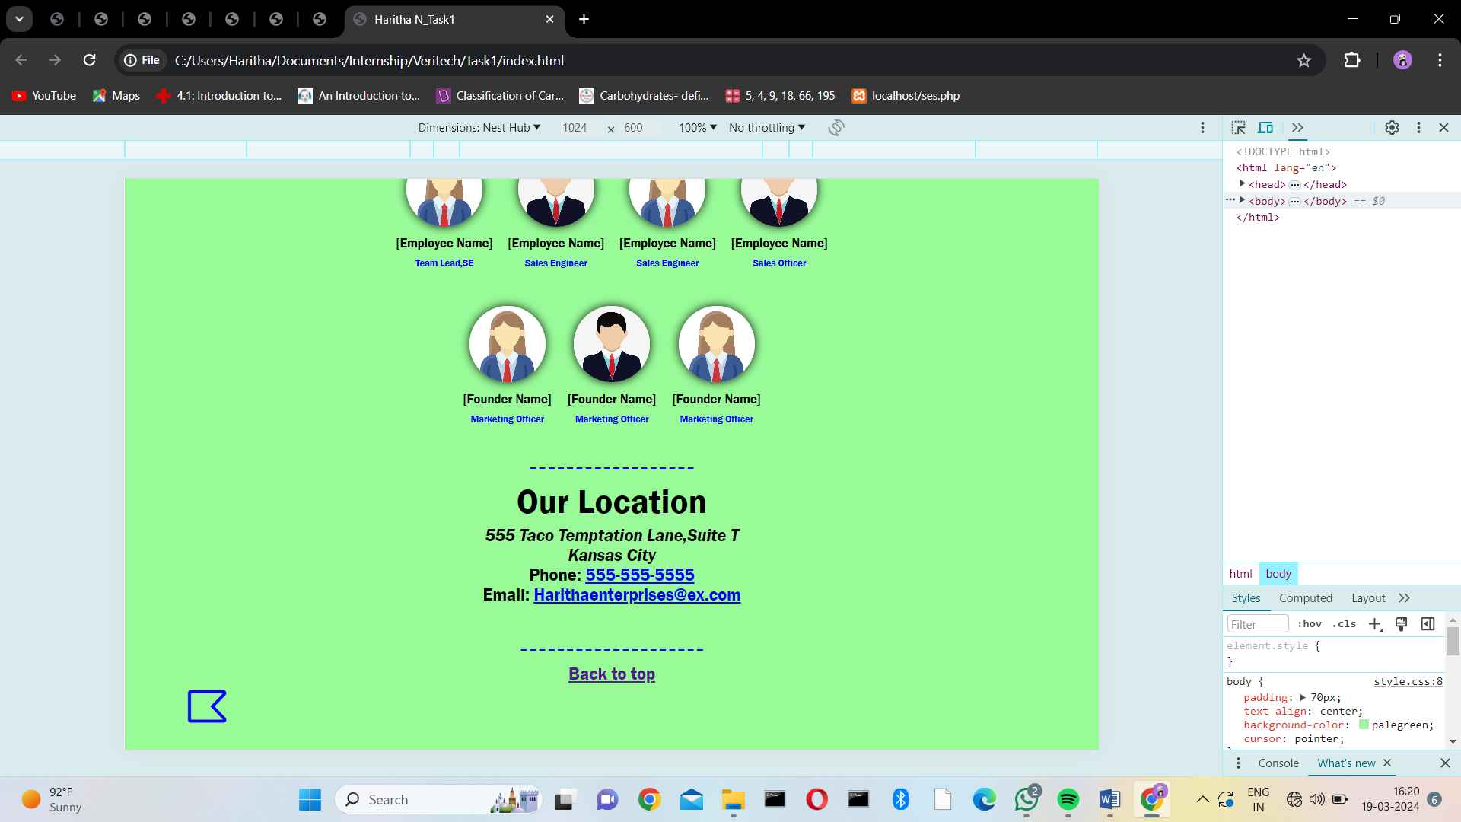

**Date: 19-03-2024**